Plant Disease Prediction

A PROJECT REPORT

Submitted by

NAITIK BHAVSAR (190303105079)

MESHWA SHAH (190303105106)

DHARM MEHTA (190303105010)

BILAL HASANJI (190303105087)

In fulfillment of the award of the degree of

BACHELOR OF TECHNOLOGY

In

Computer Science and Engineering Department

Under the Guidance of DR. AMIT BARVE

Parul University, Vadodara

2021 – 22



PARUL UNIVERSITY

CERTIFICATE

This is to Certify that Project - 1-Subject code 203105350 of 6th Semester entitled “Plant Disease Prediction”

of Group No 77.

has been successfully completed by

NAITIK BHAVSAR (190303105079)

MESHWA SHAH (190303105106)

DHARM MEHTA (190303105010)

BILAL HASANJI (190303105087)

under my guidance in partial fulfillment of the Bachelor of Technology (B.TECH) in Computer Science and Engineering of Parul University in Academic Year 2021- 2022.

Project Guide Project Coordinator

DR. Amit Barve Dr. Sonal rane

Head of Department, CSE

Dr. Amit Barve External Examiner

**ACKNOWLEDGEMENT**

Behind any major work undertaken by an individual there lies the contribution of the people who helped us to cross all the hurdles to achieve our goal. It gives us the immense pleasure to express our sense of sincere gratitude towards my respected guide Prof. Mr. Ankit Chouhan, (Assistant Professor) for his persistent, outstanding, invaluable co-operation and guidance. It is Our achievement to be guided under him. He is a constant source of encouragement and momentum that any intricacy becomes simple. We are gaining a lot of invaluable guidance and prompt suggestions from him during entire project work. We will be indebted of him forever and we take pride to work under him. I also express my deep sense of regards and thanks to Dr. Amit Barve, Head of CSE Engineering Department. I feel very privileged to have had their precious advice, guidance and leadership. Last but not the least, Our humble thanks to the Almighty God.

Student Name and Enrollment Number:

NAITIK BHAVSAR (190303105079)

MESHWA SHAH (190303105106)

DHARM MEHTA (190303105010)

BILAL HASANJI (190303105087)

I

**Abstract**

#### Plant disease detection is an Innovative and Enlightening System helping the users to know the disease, trainings or any interesting things taking place around their Area. This Organization aids the native community to keep themselves up to date about the events around their locality or zone or in their town. There are 2 things for this method to work; one for the image processing and another is machine learning.

#### Modern approaches such as machine learning and deep learning algorithm have been employed to increase the recognition rate and the accuracy of the results. Random forests are as a whole, learning method for classification, regression and other tasks that operate by constructing a forest of the decision trees during the training time. Unlike decision trees, Random forests overcome the disadvantage of over fitting of their training data set and it handles both numeric and categorical data.

#### Keywords- Image processing, Random Forests, Object detection

II

### **Table of Contents**

Content Page No

|  |  |
| --- | --- |
| Acknowledgement | I |
| Abstract | II |
| List of Tables | 1 |
| List of Figures | 2 |
| Chapter 1 INTRODUCTION | 3 |
| 1.1 Problem Statement | 4 |
| 1.2 Objectives | 4 |
| 1.3 Scope | 4 |
| Chapter 2 LITERATURE REVIEW | 5 |
| 2.1 Summary of Research Papers | 22 |
| Chapter 3 METHODOLOGY | 24 |
| 3.1 Project Flow and Methodology | 24 |
| 3.2 Future Work | 26 |
| References | 27 |

**LIST OF FIGURES**

|  |  |  |
| --- | --- | --- |
| Figure No | Figure Description | Page No |
| 2.1 | Diagram | 3 |
| 2.2 | System flow |  |
| 2.3 | Flowchart | 8 |
| 2.4 | System flow | 9 |
| 2.5 | Activity diagram | 10 |
| 2.6 | Flow chart | 11 |
| 2.7 | Diagram | 13 |
| 2.8 | Flowchart | 14 |
| 2.9 | System architecture | 15 |
| 2.10 | Architecture of typical CNN | 16 |
| 2.11 | K means clustering | 17 |
| 2.12 | Comparison | 18 |
| 2.13 | Sample images | 19 |
| 2.14 | Steps for data preprocessing | 20 |
| 2.15 | Diagram | 5 |
| 2.16 | System flow | 6 |
| 2.17 | Flowchart | 8 |
| 2.18 | System flow | 9 |
| 2.19 | Activity diagram | 10 |
|  |  | 20 |
|  |  |  |
|  |  |  |
|  |  |  |

**CHAPTER 1: INTRODUCTION**

Plant disease detection is an Innovative and Enlightening System helping the users to know the disease, trainings or any interesting things taking place around their Area. This Organization aids the native community to keep themselves up to date about the events around their locality or zone or in their town. There are 2 things for this method to work; one for the image processing and another is machine learning. The user is permitted to sight the disease only of his town while user can supplement disease connected to any town. Admin will show if any misuse or inappropriate or false disease added by any users and will take specific act. The Front end used is Android Studio and backend as SQL Server. The user has to record into the system to using this app and can bring up-to-date his details as well.The healthy leaf is shown first and so on, the user can also restore the disease resultant the latest one shown first and current disease will be shut. The user can add a image and a title connected to the leaf

Pests and Diseases results in the destruction of crops or part of the plant resulting in decreased food production leading to food insecurity. Also, knowledge about the pest management or control and diseases are less in various less developed countries. Toxic pathogens, poor disease control, drastic climate changes are one of the key factors which arises in dwindled food production. Various modern technologies have emerged to minimize postharvest processing, to fortify agricultural sustainability and to maximize the productivity. Various Laboratory based approaches such as polymerase chain reaction, gaschromatography, mass spectrometry, thermography and hyper spectral techniques have been employed for disease identification. However, these techniques are not cost effective and are high time consuming

There are 2 things for this method to work; one for the image processing and another is machine learning. The user is permitted to sight the disease only of his town while user can supplement disease connected to any town. Admin will show if any misuse or inappropriate or false disease added by any users and will take specific act. The Front end used is Android Studio and backend as SQL Server. The user has to record into the system to using this app and can bring up-to-date his details as well. The healthy leaf is shown first and so on, the user can also restore the disease resultant the latest one shown first and current disease will be shut. The user can add a image and a title connected to the leaf.

1.1 Problem statement

The problem of efficient plant disease protection is closely related to the problems of sustainable agriculture and climate change. Research results indicate that climate change can alter stages and rates of pathogen development; it can also modify host resistance, which leads to physiological changes of host-pathogen interactions. The situation is further complicated by the fact that, today, diseases are transferred globally more easily than ever before

1.2 Objective

Modern approaches such as machine learning and deep learning algorithm has been employed to increase the recognition rate and the accuracy of the results. Random forests are as a whole, learning method for classification, regression and other tasks that operate by constructing a forest of the decision trees during the training time. Unlike decision trees, Random forests overcome the disadvantage of over fitting of their training data set and it handles both numeric and categorical data.

1.3 Scope

This single project serves many users to view several disease.To find out whether the leaf is diseased or healthy, certain steps must be followed. Preprocessing of image, is bringing all the images size to a reduced uniform size. Then comes extracting features of a preprocessed image which is done with the help of HOG .HoG is a feature descriptor used for object detection. In this feature descriptor the appearance of the object and the outline of the image is described by its intensity gradients

CHAPTER 2: Literature survey

**PAPER 1**: PLANT DISEASE DETECTION BY IMAGING SENSORS

**PUBLICATION**: INRES

**DATE**: Jan 2016

Abstract:

Early and accurate detection and diagnosis of plant diseases are key factors in plant production and the reduction of both qualitative and quantitative losses in crop yield. Optical techniques, such as RGB imaging, multi- and hyperspectral sensors, thermography, or chlorophyll fluorescence, have proven their potential in automated, objective, and reproducible detection systems for the identification and quantification of plant diseases at early time points in epidemics. Recently, 3D scanning has also been added as an optical analysis that supplies additional information on crop plant vitality. Different platforms from proximal to remote sensing are available for multiscale monitoring of single crop organs or entire fields. Accurate and reliable detection of diseases is facilitated by highly sophisticated and innovative methods of data analysis that lead to new insights derived from sensor data for complex plant-pathogen systems. Nondestructive, sensor-based methods support and expand upon visual and/or molecular approaches to plant disease assessment. The most relevant areas of application of sensor-based analyses are precision agriculture and plant phenotyping.

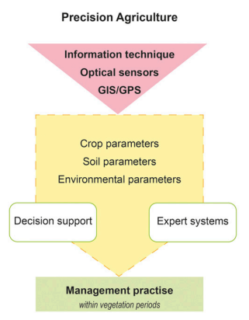fig. 2.1

Conclusion:

Only a highly interdisciplinary approach with a close link to practical agriculture can lead to powerful solutions for diagnosis and disease detection with a high accuracy and sensitivity that will improve plant health management. This research is done for predicting and detecting the diseases present in the various parts of plants like stems, leaves and fruits. For future research, it is indispensable to link complementary research fields, such as plant pathology, sensor development, informatics, and machine learning. Only a highly interdisciplinary approach with a close link to practical agriculture can lead to powerful solutions for diagnosis and disease detection with a high accuracy and sensitivity that will improve plant health management.

**PAPER 2**: Plant Leaf Disease Prediction

**PUBLICATION**: Research Gate

**DATE**: July 2021

Abstract:

The Indian economy relies heavily on agriculture productivity. A lot is at stake when a plant is struck with a disease that causes a significant loss in production, economic losses, and a reduction in the quality and quantity of agricultural products. It is crucial to identify plant diseases in order to prevent the loss of agricultural yield and quantity.

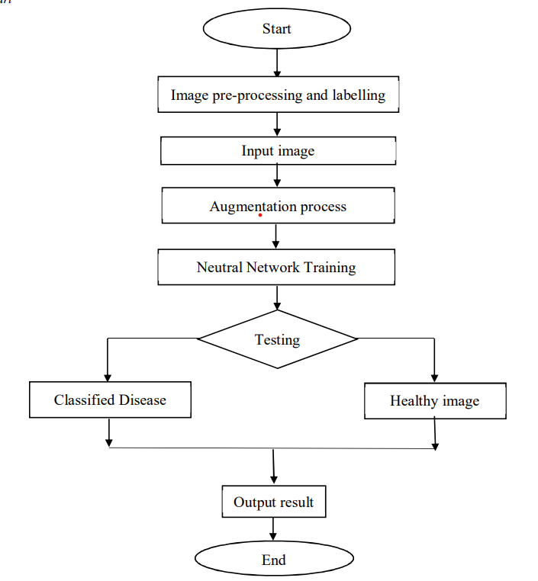 fig. 2.2

Conclusion:

Even after having all the facilities, we are lacking in some of the terms to detect the disease in the plant and save them from dying. The new generation of convolutional neural networks (CNNs) has shown promising results in the field of image recognition. With an accuracy of 90%, the developed model could distinguish healthy leaves from eight diseases that could be observed visually. On the basis of this high level of performance, it becomes apparent that convolutional neural networks are highly suitable for automatic diagnosis and detection of plants.Over the last few years, there has been tremendous progress in the performance of convolutional neural networks. The new generation of convolutional neural networks (CNNs) has shown promising results in the field of image recognition. A novel approach to automatically classifying and detecting plant diseases from leaf images was examined through this project utilizing deep learning techniques. With an accuracy of 90%, the developed model could distinguish healthy leaves from eight diseases that could be observed visually. On the basis of this high level of performance, it becomes apparent that convolutional neural networks are highly suitable for automatic diagnosis and detection of plants.

**PAPER 3**: IMAGE BASED SYSTEM USING DEEP LEARNING

**PUBLICATION**: RESEARCH GATE

**DATE**: August 2022

Abstract:

Plant diseases mostly harm the leaves, resulting in a loss in agricultural output's quality and quantity. Plant disease is the most common cause of large-scale crop mortality. India is a country where people's livelihoods are heavily reliant on agriculture. The disease has caused chaos in the agricultural industry. The human eye's perception is not quite as sharp as it needs to be to notice minute variations in the sick leaf region. It needs a complex process that requires both plant expertise and a large amount of processing time. As a result, plant diseases can be detected using machine learning. The disease detection method includes image acquisition, image pre-processing, image segmentation, feature extraction, and classification. To prevent crops at the initial stage from diseases, it is essential to develop an automatic system to diagnose plant diseases and identify its category. The goal of the proposed research is to examine several machine algorithms for plant disease prediction. The paper proposed a framework for disease and healthiness detection in plants and the classification of diseases based on symptoms appearing on a leaf. The diseases are grouped into three categories in the paper: bacterial, viral, and fungal. To conclude, the research paper investigates all of these factors and uses several machine learning(DL) techniques and deep learning(DL) techniques. The machine learning(ML) techniques used in the research work are SVM, KNN, RF(Random Forest), LR (Logistic Regression), and the deep learning(DL) technique used is-Convolutional Neural Network(CNN) for disease prediction in the plants. Following that, a comparison of machine learning and deep learning methodologies was conducted. The RF(Random forest) has the highest accuracy of 97.12 % among machine learning classifiers, however, in comparison to the deep learning model mentioned in the study, the CNN classifier has the highest accuracy of 98.43 %.

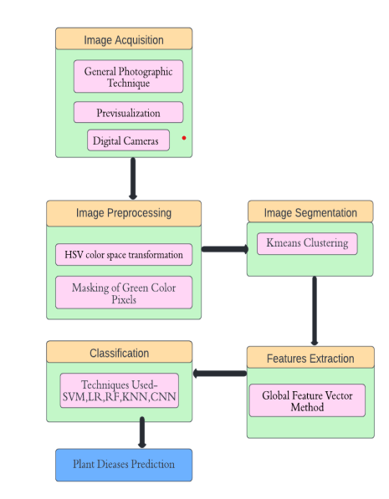fig. 2.3

Conclusion:

In this research article, an approach for plant disease prediction and classification has been proposed using deep learning and machine learning classifiers. Classification is performed after the segmentation and feature extraction process. Diseases have been broadly classified into three categories namely Fungal, Bacterial and viral. A dataset consisting of 5,3200 images has been trained upon SVM, KNN, Logistic Regression, Random Forest, and CNN. Among all the classifiers, CNN gives the best prediction accuracy of 97.34%. In the future, image augmentation can also be applied to the dataset to increase its size and compare the results between all classifiers as well as The agricultural department seeks to automate the process of recognizing high-yield crops (real-time). This method can be automated by displaying the prediction result in a web or desktop application. To make the work easier to implement in an Artificial Intelligence context

# **PAPER 4**: Disease Prediction using ML

**PUBLICATION**: RESEARCH GATE

**DATE**: November 2021

Abstract:

Machine learning is computer programming to optimize performance using sample data or past data. Machine learning is the study of computer systems that learn from data and experience. The machine-learning algorithm has two parts: training, testing. Predict disease using symptoms and patient history Machine learning technology has been striving for decades. Machine learning technology provides an immeasurable platform in the medical field for health issues to be effectively resolved. We apply machine learning to keep complete hospital data. leading to the reference in the current text must match the list of references at the end of the document. Healthcare is a vast field in which computer technology is steadily being incorporated into various technologies, mainly Machine Learning algorithms and hospital-generated datasets. Supervised Machine Learning algorithms are Vindication in the healthcare industry. With the help of this project, we will detect the disease at the earliest stage and apply the necessary treatment. We are testing the accuracy of various models using the given dataset. To our knowledge, in large scale medical data analysis no prior work has addressed both types of data. Our proposed algorithm is more accurate with 94.8% calculation accuracy and faster convergence speed than other typical estimation algorithms as compared to CNN based unimodal disease prediction.

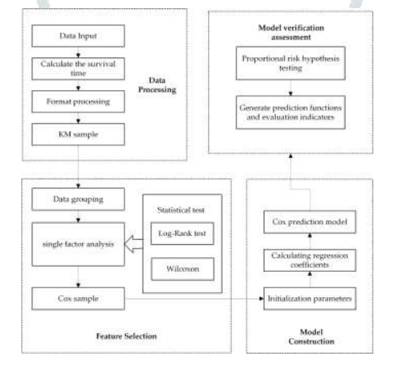fig. 2.4

Conclusion:

Comparing the accuracy between random forest, naïve bayes and decision tree algorithm. We conclude that random forest has the highest accuracy as compared to the other 2 algorithms. But for our project all 3 models are combined to give the best accuracy output. By using the 3 different methods namely, random forest, naïve bayes and decision tree algorithm, out of all of these, Random Forest gives the accurate result and is very suitable for predicting the diseases in the plants. But in our project, for obtaining more better outputs, all the 3 methods are put in together.

**PAPER 5**: Forecasting Plant and Crop Disease

**PUBLICATION**: MDPI

**DATE**: Jan 2021

Abstract:

Crop and plant diseases entail serious implications for food security and production losses. Over the years, the lasting global trade and the changing climate have not only exacerbated the existing favorable conditions for plant and crop disease but have also created new conditions with which agriculture must now contend.

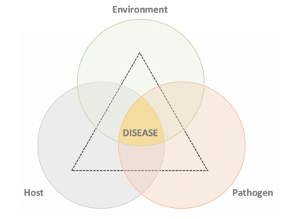fig. 2.5

Conclusion:

The prediction of plant and crop disease is a complex problem to be solved due to the interaction of several environmental and climatic factors. Over the last 10 years, the literature has presented considerable advancements in understanding these dynamic processes by adopting different scientific approaches. As we observed, the problem under study requires high-quality, labeled data. However, the lack of open data is slowing the advance of knowledge in this agricultural sub-domain. Indeed, regarding the state of the art, only a limited number of contributions has been presented in the literature from 2010 to today. The majority of these have focused on few pathogens and crops; furthermore, only a few of these have considered data from various heterogeneous sources to predict disease occurrence. These gaps are hindering progress in achieving development goals and creating products that are able to face realworld scenarios, and so more effort is required in data collection and in developing novel solutions to prevent and mitigate the impact of crop and plant disease to food production, especially for those crops which represent staple foods for millions of people who live in the least developed countries.

**Paper 6** : VARIOUS PLANT DISEASES DETECTION USING IMAGE PROCESSING METHODS

**PUBLICATION**: IJSDR

**DATE**: JUNE 2019

Abstract:

Identification of plant leaf diseases is the preventive measure for the loss happened in the yield and the overall agriculture crop quantity. Basically, the studies of the plant diseases are defined by visualizing and observing patterns observed and engraved on the leaves. So, the disease detection of any plant prior to any hazardous impact becomes very crucial factor for viable agriculture. However, it is so difficult to detect, monitor and derive conclusions from the plant leaf diseases manually because, the costs emerging in the process demands huge amount of workdone, energy, expertize and last but not least the processing time. Therefore, image processing concepts comes handy and are used for disease detections.The detection process includes the phases such as, image acquisition, segmentation, image pre-processing, feature extraction from segments and then classification based on the results. This paper discusses the elementary methods that are being used for the plant disease detection based on the leaf images.

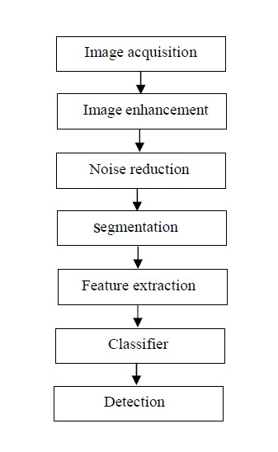

Fig 2.6

CONCLUSION:

Plant disease detection have a significant role in today’s era as with the development in every fields there is also a development in the plant disease detection stage. There is a invention of the new program named KNN where we can find out more than one disease very easily and detect them.

This paper conjointly mentioned some feature extraction, clustering, acquisition and classification techniques used to detect the exact diseases which are infecting either the leaves or stems of the plants.

**PAPER 7**: Plant Disease Detection using Image Processing

**PUBLICATION**: IJERT

**DATE**: MARCH 2020

Abstract:

Identification of the plant diseases is the key to prevent the losses in the yield and quantity of the agricultural product. Health monitoring and disease detection on plant is very critical for sustainable agriculture. It is very difficult to monitor the plant diseases manually. It requires tremendous amount of work, expertise in the plant diseases, and also require the excessive processing time. Hence, image processing is used for the detection of plant diseases by capturing the images of the leaves and comparing it with the data sets. The data set consist of different plant in the image format. Apart from detection users are directed to an e-commerce website where different pesticides with its rate and usage directions are displayed. This website can be efficiently used for comparing the MRP’s of different pesticides and purchase the required one for the detected disease. This paper aims to support and help the green house farmers in an efficient way.

Conclusion:

This research is done for predicting and detecting the diseases present in the various parts of plants like stems, leaves and fruits. This work is implemented by having several plant disease images. It is implemented from scratch and produces a decent accuracy. The future work aims on providing more accuracy. The classification of plant leaf diseases has been described later.

**PAPER 8**: Plant Disease Detection using Image Processing

**PUBLICATION**: IJERT

**DATE**: JUNE 2020

Abstract: The existing system the farmers are using for the detection of diseases in the plants is that- they could be identified through the naked eye and there knowledge about plant disease. For doing so, on large number of plants is time consuming, difficult and accuracy is not good. Consulting experts is of great cost. In such kind of conditions to improve the accuracy rate and make it more beneficial suggested techniques are implemented where devices are used for the automatic detection of the diseases that makes the process cheaper and easier.

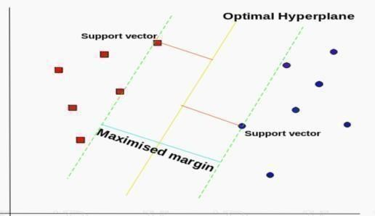

Fig 2.7

Conclusion:

This paper gives the survey on different diseases classification techniques that can be used for plant leaf disease detection. This project is carried out to identify the problems, defects and diseases in the leaves of the plants by using the factors like shape, texture, color and many more.

Images are read In MATLAB and processes them automatically on SVM. Firstly, healthy and diseased images are composed and pre-processed. Later, attributes like shape, color and texture are taken out from these images. Finally, these images are sorted by means of support vector machine (SVM).

**PAPER 9**: Plant Leaf Disease Detection using Machine Learning

**PUBLICATION**: IJERT

**DATE**: JUNE 2019

Abstract:

Indian economy generally depends on agricultural productivity. It is natural to have a disease on plants so that detection of disease plays an important role in agriculture. The main motto is to implement image analysis and classification techniques for detection of leaf diseases and classification. This method consists of four parts. They are Image preprocessing, Segmentation of the leaf, feature extraction and classification of diseases.

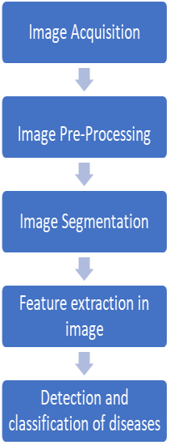

Fig 2.8

CONCLUSION:

This paper represents a review of the technical implementation in the research area of plant disease detection using image processing technique. Provides usefulness of various algorithms and gives the appropriate solution to the problem. ANN and SVM are most commonly used techniques used for classification of diseases in any plant leaf. This detection of diseases in plant nowadays helps the farmer to improve the crop quality and helps in improving the total GDP.

**PAPER 10**: PLANT DISEASE DETECTION BY IMAGE PROCESSING

**PUBLICATION**: INRES

**DATE**: 2019

Food is one of the basic needs of human being. World population is increasing day by day. So it has become important to grow sufficient amount of crops to feed such a huge population. But with the time passing by, plants are affected with various kinds of diseases, which cause great harm to the agricultural plant productions. Beside that many countries economy greatly depends on agricultural productivity and it’s also a need for a coun try to attain agricultural productivity of basic agricultural product for the people of that particular country. Detection of plant disease through some automatic technique is beneficial as it requires a large amount of work of monitoring in big farm of crops, and at very early stage itself it detects symptoms of diseases means where they appear on plant leaves.

I. Image Acquisition

1

. Pick up a leaf from plants

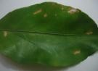

2

.

Capture

leaf image

II. Image Preprocessing

1

. Image Enhancement

2

. Colorspace conversion

. Image segmentation

3

III.

Feature

Extraction

IV.

Classification

V.

Diagnosis

Of diseases

Fig 2.9

Conclusion:

Here, to get the solution to our problem and detect the illness of the crop, related diseases for these plants were taken for identification. The optimum results were obtained which also shows the efficiency of algorithm. To improve recognition rate in classification process Artificial Neural Network, Bayes Classifier, Fuzzy Logic and hybrid algorithms can also be used.

**PAPER 11**: Plant disease detection using hybrid model based on convolutional autoencoder and convolutional neural network

**PULISHER:** KeAi Communications Co., Ltd

**DATE OF PUBLICATION:** MAY2021

**ABSTRACT:**

In this work, the given hybrid model used is apple to detect bacterial spot disease presents in peach plants using images, however, it can be used in any plant disease detection. System used In this research paper achieves 99.35% training accuracy and 9914 training parameters. Due to small training data set it decreases the time required to train the model for automatic plant disease detection and the time required to identify the disease in plants. 75% population of india depends on the agriculture sector. (CNNs) and (CAEs) deep learning techniques are used in many computers vision applications due to their effectiveness on image data.

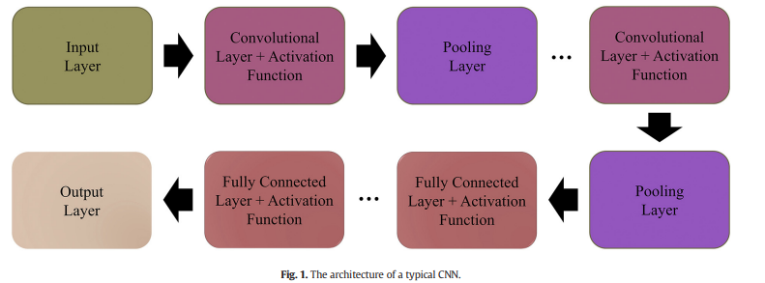fig-2.10

**CONCLUSION:**

In this paper, a novel hybrid model was proposed for automatic plant disease detection that was based on two Deep Learning techniques named Convolutional Autoencoder (CAE) network and Convolutional Neural Network (CNN). Other researches have done experiment too using different techs like Resnet-152, VGG-19, inception V3, etc. but in Resnet-152 it used 60 million testing parameters and VGG-19 used 143 million and provided 99% and 98% accuracy

**PAPER 12:** PLANT DISEASE DETECTION USING IMAGE PROCESSING AND MACHINE LEARNING ALGORITHM

**PULISHER:** ResearchGate

**DATE OF PUBLICATION:** JAN2022

**ABSTRACT:**

In this research paper they observed pomegranate and potato plant’s disease. They have firstly performed image acquisition where image were captured by digital camera and image processing for image improvement and image segmentation. They used K-means clustering and CNN also. This experiment provided in this research paper was performed on software called MatLab. The given system for prediction of disease of both plants mostly depends on the image processing K-means, and neural network.

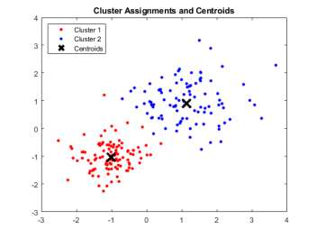

Figure 2.11: K-mean clustering

**CONCLUSION:**

Here, K-means clustering algorithm is used for disease classification and Neural Network algorithm is used to predict the disease of both plants where as the epoch of 2000 is used to obtain much more accuracy .In this experiment they have used 10 hidden layers and because of that it obtains higher accuracy. For pomegranate the accuracy was 89.9% and for potato leaf accuracy was 91% for disease detection

**PAPER 13:** Plant Disease Detection and Classification by Deep Learning

**PULISHER:** IEEE

**DATE OF PUBLICATION:** APR2021

**ABSTRACT:**

Here, in this paper they have discussed about deep learning for plant disease detection. Deep learning can make plant disease feature extraction more objective, and improve the research efficiency and technology transformation speed. This review provides the research progress of deep learning technology in the field of crop leaf disease identification. With the help of K-means clustering method to segment the lesions region and combined the (GCH), (CCV), (LBP), (CLBP) Dubey and jalal extracted the color and texture features of apple spots, and three kinds of apple disease were detected and accuracy reached 93%.

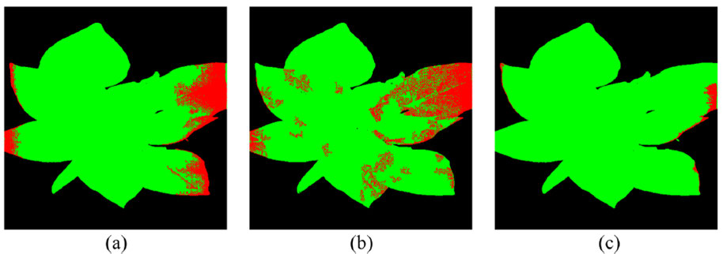

FIGURE 2.12. Comparison of segmentation results of a typical healthy plant. (a)direct CNN model. (b)AC-GAN model. (c)the proposed OR-AC-GAN model.

**CONCLUSION:**

In this paper, They have introduced the basic knowledge of deep learning and presented a comprehensive review of recent research work done in plant leaf disease recognition using deep learning. problems that affect the widespread use of HSI in the early detection of plant dis_eases remain to be resolved.

**PAPER 14:** Article Plant Disease Detection Using Deep Convolutional Neural Network

**PULISHER:** MDPI

**DATE OF PUBLICATION:** JULY2021

**ABSTRACT:**

In this research, they proposed a novel 14-layered Deep Convolutional Neural Network (14-DCNN) to detect plant leaf disease using leaf image. In this research, they have used three image augmentation techniques. (i) Basic Image Manipulation (BIM), (ii) Deep Convolutional generative adversarial network (DCGAN), (iii) Neural Style Transfer (NST). They have used 147,500 images of 58 different healthy and diseased plant leaf classes and one no-leaf class. Transfer learning uses the pre-trained neural network from one task to a similar new task.

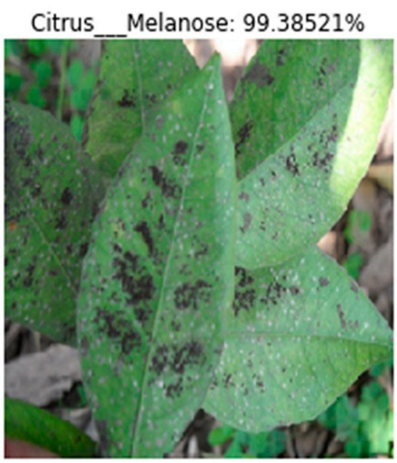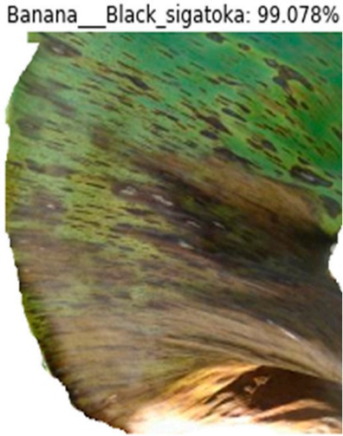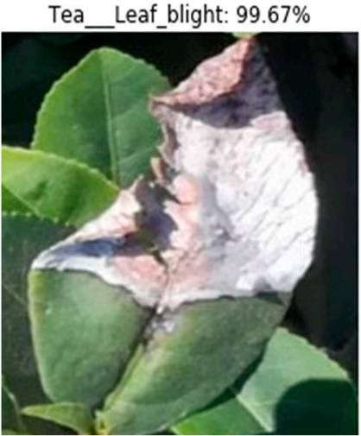 Figure 2.13 . Sample predicted images using the 14-DCNN model.

CONCLUSION:

A novel DCNN model was proposed to detect plant leaf diseases from leaf images in this research. The proposed 14-DCNN model was designed and trained to detect 42 leaf diseases in 16 plants through leaf images. In future, estimate the possibility of plant disease and analyze the severity using the deep learning technique. Moreover, we will extend disease detection from plant leaves to other parts of the plants, such as flowers, fruits, and stems.

**PAPER 15:** Plant Disease Detection Using Image Processing and Machine Learning

**PULISHER:** VIT, Pune, India

**DATE OF PUBLICATION:** 2021

**ABSTRACT:**

This paper proposes use of computer vision and machine learning technique for detection of crop disease. Here, proposed system is able to detect 20 different disease of 5 common plants. Here, in this paper they have discussed about other technologies for plant disease detection. Like (BPNN), (GLCM), color and texture analysis feature. With those technologies they have achieved 83% of accuracy. In this paper they have selected the feature on the basis of correlation of variables with target variable.

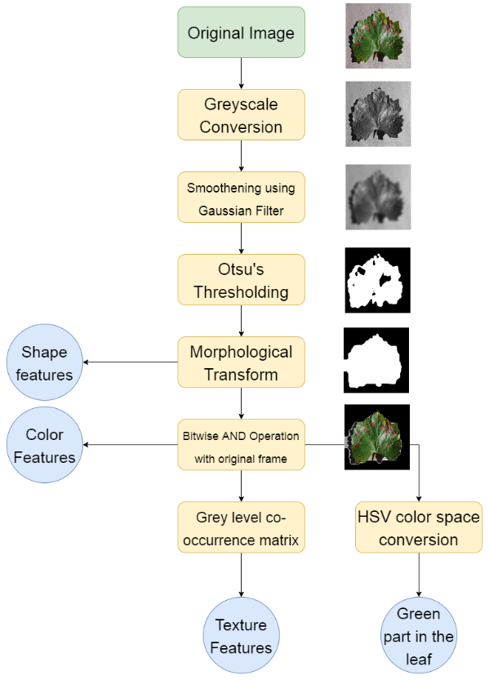

Fig. 2.14. Steps for data preprocessing and feature extraction.

CONCLUSION:

Here proposed system is able to detect 20 different diseases of 5 common plants with 93% accuracy. They have successfully developed a computer vision based system for plant disease detection with average 93% accuracy and 0.93 F1 score. Also the proposed system is computationally efficient because of the use of statistical image processing and machine learning model. We can observe that their technique is accurate and efficient compared with other systems. Also it won't require a specialized hardware, makes it cost effective solution.

**Paper 16**: Early Prediction of Plant Diseases using CNN and GANs

**DATE**: November 5 2021

ABSTRACT

Abstract—Plant diseases enormously affect the agricultural crop production and quality with huge economic losses to the farmers and the country. This in turn increases the market price of crops and food, which increase the purchase burden of customers. Therefore, early identification and diagnosis of plant diseases at every stage of plant life cycle is a very critical approach to protect and increase the crop yield. In this paper using a deep-learning model, we present a classification System based on real-time images for early identification of plant infection prior of onset of severe disease symptoms at different life stages of a tomato plant infected with Tomato Mosaic Virus

(TMV). The proposed classification was applied on each stage of the plant separately to obtain the largest data set and manifestation of each disease stage. The plant stages named in relation to disease stage as healthy (uninfected), early infection, and diseased (late infection). Classification was designed using the Convolutional Neural Network (CNN) model and the accuracy rate was 97%. Using Generative Adversarial Networks (GANs) to increase the number of real-time images and then apply CNN on these new images and the accuracy rate was 98 percent.

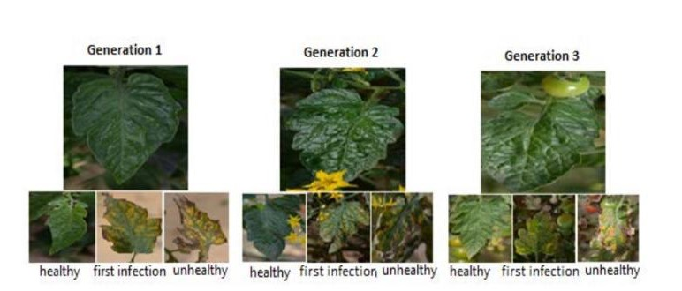2.15

CONCLUSION

To summarize, DL was used in early prediction to detect diseases in different plant growth stages using the CNN algorithm for classification and prediction. Here, using the tomato infected with TMV as a model, the accuracy rate of TMV infection was 97%. The GANs used to increase the size of data and prediction accuracy rate by 98% when compared to the original data. For each plant growth phase, it became clear that the most growth stage group is vulnerable to viral infection is the second group. Therefore that determining the growth stages in this paper helped at obtaining results that prove the age group most susceptible to Unhealthy by determining the stages of Unhealthy also (healthy – first infection - Unhealthy), Thus, the study has concluded the previous results by applying to a set of real data that was collected manually from one of the farms in Egypt. Future work will include several DL models for early detection and classification of plant diseases due to using the rapid progress and improvements in DL models, transfer learning techniques, and CNN frameworks. Larger real-time dataset of TMVinfected tomato plants, and other important plant-disease system will be tested for attaining highest prediction accuracy.

.Building a robust and accurate digital and computer-based plant pest-infestations and microbial disease-infections earlydetection and warning system, will significantly help plant protection in early stages, with increased yield, quality, local marketing, and international exporting competitiveness

**Paper 17:** PRGdb 3.0: a comprehensive platform for prediction and analysis of plant disease resistance genes.

**Published** : 16 November 2017

ABSTRACT

The improved section on plant diseases displays useful information linked to genes and genomes to connect complementary data and better address specific needs. Through, a revised and enlarged collection of data, the development of new tools and a renewed portal, PRGdb 3.0 engages

the plant science community in developing a consen- sus plan to improve knowledge and strategies to fight diseases that afflict main crops and other plants.

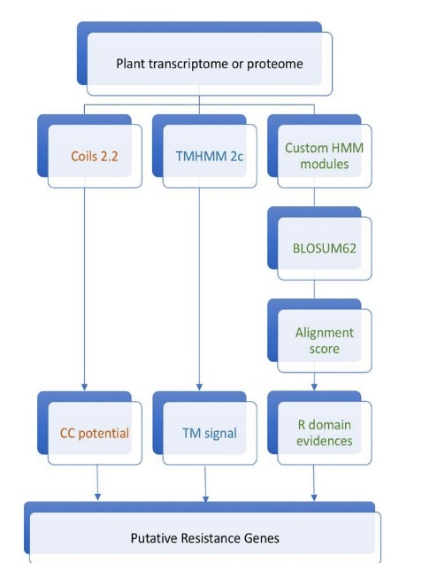2.16

CONCLUSION

The ability of investigators to use this data meaningfully is highly dependent on efficient technology search and data management that is best housed in a com- munity resource such as PRGdb. We will continue to in- corporate new data as they become available, including se- quence and gene expression data from large-scale genomics projects. Several groups are planning to share manually cu- rated PRG annotations in different species and transcrip- tomic data related to pathogen plant response.

**Paper 18:** A Survey on Plant Disease Prediction using Machine Learning and Deep Learning Techniques.

**Published**: 2019

ABSTRACT

The major agricultural products in India are rice, wheat, pulses, and spices. As our population is increasing rapidly the demand for agriculture products also increasing alarmingly. A huge amount of data are incremented from various field of agriculture. Analysis of this data helps in predicting the crop yield, analyzing soil quality, predicting disease in a plant, and how meteorological factor affects crop productivity. Crop protection plays a vital role in maintaining agriculture product. Pathogen, pest, weed, and animals are responsible for the productivity loss in agriculture product. Machine learning techniques like Random Forest, Bayesian Network, Decision Tree, Support Vector Machine etc. help in automatic detection of plant disease from visual symptoms in the plant. A survey of different existing machine learning techniques used for plant disease prediction was presented in this paper. Automatic detection of disease in plant helps in early diagnosis and prevention of disease which leads to an increase in agriculture productivity.

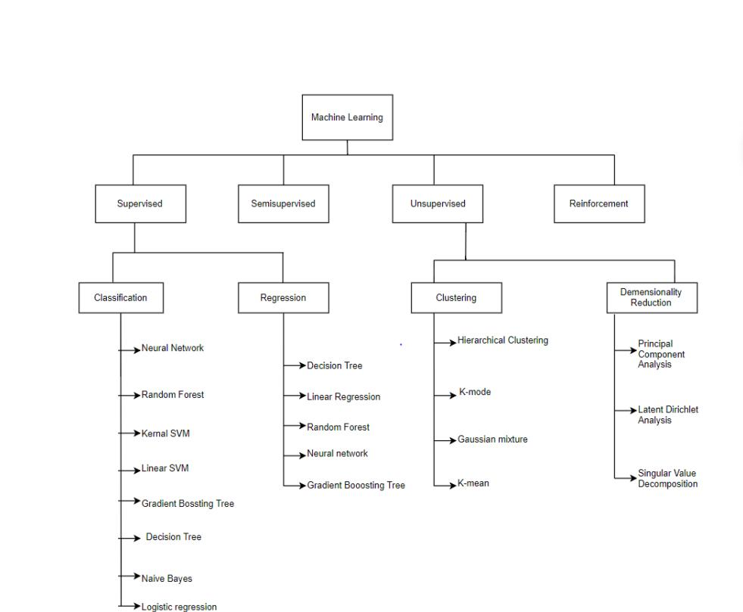2.17

CONCLUSION

The key objective of this work is to analyze different machine learning techniques widely used in the prediction of plant diseases and how advancement can be made in the future in this technique to achieve higher accuracy, robustness, cost-efficient disease prediction system. The steps involved in image processing techniques like pre-processing, segmentation, extracting feature and classification based on symptoms in the plant are discussed in this survey. Machine learning techniques play a key role in the machine vision system. In the future, deep learning framework can be used for disease prediction system. Integrating image processing techniques and deep learning techniques proved to be more potential in disease prediction system.

**Paper 19:** Parameter estimation and prediction for the course of a single epidemic outbreak of a plant diseases.

**Published**: 17 July 2007

ABSTRACT

provide guidelines for predicting and controlling disease outbreaks.This task can be achieved only if a reliable model is available and successfully parametrized. The model can subsequently be used to assess the impact of treatments on potential outbreaks and to predict future epidemics. Parameter estimation and subsequent testing of models against data form key steps in modelling ecological and epidemiological processes. However, these steps are not often given enough emphasis (Pascual & Kareiva 1996), owing to the lack of studies combining highly controllable experimental systems and involving biologically plausible yet tractable models.

Conventionally, epidemiologists consider single out- breaks for which some parameters are estimated from independent studies, while others are found based on the whole or part of the current outbreak .

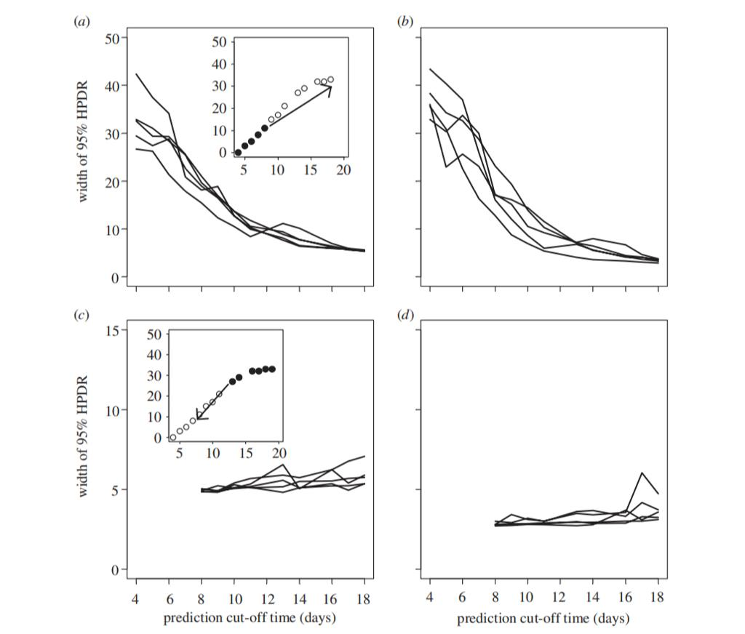2.18

CONCLUSION

In the exponential phase of disease spread, small differences in the initial conditions are magnified by the subsequent dynamics. This generates large differences among realizations while keeping the individual growth curves relatively smooth. Since many biological processes are adequately approximated by the exponential function, we suggest that the method developed here can be applied to many epidemiological, ecological and even metabolic processes.

**Paper 20**:Automatic Image-Based Plant Disease Severity Estimation Using Deep Learning

**Published**: 2019

ABSTRACT:

Automatic and accurate estimation of disease severity is essential for food security, disease management, and yield loss prediction. Deep learning, the latest breakthrough in computer vision, is promising for fine-grained disease severity classification, as the method avoids the labor-intensive feature engineering and threshold-based segmentation. Using the apple black rot images in the PlantVillage dataset, which are further annotated by botanists with four severity stages as ground truth, a series of deep convolutional neural networks are trained to diagnose the severity of the disease. The performances of shallow networks trained from scratch and deep models fine-tuned by transfer learning are evaluated systemically in this paper. The best model is the deep VGG16 model trained with transfer learning, which yields an overall accuracy of 90.4% on the hold-out test set. The proposed deep learning model may have great potential in disease control for modern agriculture.

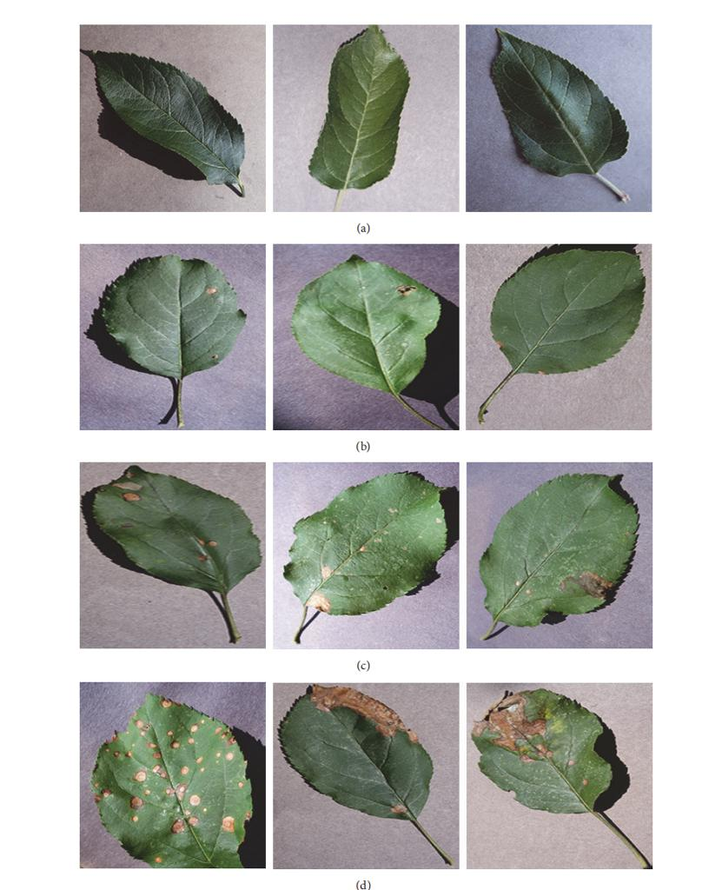2.19

CONCLUSION

This work proposes a deep learning approach to automat- ically discover the discriminative features for fine-grained classification, which enables the end-to-end pipeline for diagnosing plant disease severity. Based on few training samples, we trained small convolutional neural networks of different depth from scratch and fine-tuned four state- of-the-art deep models: VGG16, VGG19, Inception-v3, and ResNet50. Comparison of these networks reveals that fine- tuning on pretrained deep models can significantly improve the performance on few data. The fine-tuned VGG16 model performs best, achieving an accuracy of 90.4% on the test set, demonstrating that deep learning is the new promising tech- nology for fully automatic plant disease severity classification.

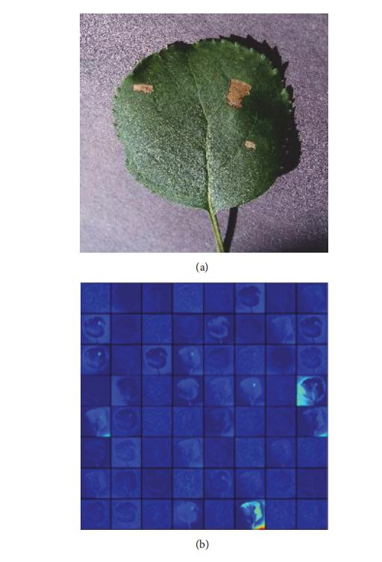

## 2.1 SUMMARY OF RESEARCH PAPERS

|  |  |  |  |  |
| --- | --- | --- | --- | --- |
| **No.** | **Title** | **Publication** | **Year** | **Overview** |
| 1 | PLANT DISEASE DETECTION BY IMAGING SENSORS | INRES | 2016 | attain real-time, robust mapping systems for crop, soil, and environment variables to facilitate a management decision. |
| 2 | Plant Leaf Disease Prediction | Research Gate | 2021 | With an accuracy of 90%, the developed model could distinguish healthy leaves from eight diseases that could be observed visually. |
| 3 | IMAGE BASED SYSTEM USING DEEP LEARNING | Research Gate | 2022 | image augmentation can also be applied to the dataset to increase its size |
| 4 | Disease Prediction using ML | Research Gate | 2021 | random forest has the highest accuracy as compared to the other 2 algorithms. |
| 5 | : Forecasting Plant and Crop Disease | MDPI | 2021 | digital technologies contribute to improving our understanding by continuously monitoring and measuring different physical phenomena producing a huge amount of data |
| 6 | VARIOUS PLANT DISEASES DETECTION USING IMAGE PROCESSING METHODS | IJSDR | 2019 | useful for the initial disease detections in the leaves of the plant and prevent it's increasing flow to reach to the stem and roots of the plants. |
| 7 | Digital image processing techniques for detecting, quantifying and classifying plant diseases | SPRINGER | 2013 | Provides the technical solution for detection the disease in plants. Methods are too specific.Operation conditions are too strict |
| 8 | Plant Disease Detection using Image Processing | IJERT | 2020 | Helps in capturing the diseased part of the lead of the plant automatically. |
| 9 | : Plant Leaf Disease Detection using Machine Learning | IJERT | 2019 | helps the farmer to improve the crop quality which helps in improvement of Indian gross domestic product (GDP). Large complexity of network structure during back propagation. |
| 10 | [An Overview of the Research on Plant Leaves Disease detection using Image Processing Techniques](https://www.researchgate.net/publication/314436486_An_Overview_of_the_Research_on_Plant_Leaves_Disease_detection_using_Image_Processing_Techniques?enrichId=rgreq-fb496db85255ff0d2168de6e1d32c012-XXX&enrichSource=Y292ZXJQYWdlOzMxNDQzNjQ4NjtBUzo3ODM4MjQ2NDQ0ODUxMjJAMTU2Mzg4OTc2NjgxMA%3D%3D&el=1_x_3&_esc=publicationCoverPdf) | Research Gate | 2014 | This method is used to analyse the healthy and diseased plants.  Shows a good potential Too much effect of background data in the resulting image. |
| 11 | Plant disease detection using hybrid model based on convolutional autoencoder and convolutional neural network | KeAi Publishing | 2021 | If the diseases are not identified in the early stages, then they may adversely affect the total yield, resulting in a decrease in the farmers' profits |
| 12 | PLANT DISEASE DETECTION USING IMAGE PROCESSING AND MACHINE LEARNING ALGORITHM | Research Gate | 2022 | The image processing along with k-means clustering  and convoluted neural networking algorithms could be used for the accurate  prediction of the disease |
| 13 | Plant Disease Detection and Classification by Deep Learning | IEEE | 2021 | The application of deep learning in plant disease  recognition can avoid the disadvantages caused by artificial selection of disease spot features. |
| 14 | Article Plant Disease Detection Using Deep Convolutional Neural Network | MDPI | 2022 | the overall  performance of the proposed DCNN model was better than the existing transfer learning approaches. |
| 15 | Plant Disease Detection Using Image Processing and Machine Learning | VIT Pune | 2021 | The proposed system is able to detect 20 different diseases of 5 common plants with 93% accuracy. |
| 16 | Early prediction and plant disease using CNN and GANs | researchgate | 2021 | Classification system based 0n real-time images for identification of early plant diseas using deep learning module |
| 18 | A Survey on Plant Disease Prediction using Machine Learning and Deep Learning Techniques. | ReasearchGate | 2019 | A Survey on Plant Disease Prediction using Machine Learning and Deep Learning Techniques. |
| 19 | Parameter estimation and prediction for the course of a single epidemic outbreak of a plant diseases. | ReasearchGate | 2007 | Conventionally, epidemiologists consider single out- breaks for which some parameters are estimated from independent studies, while others are found based on the whole or part of the current outbreak . |
| 20 | Automatic Image-Based Plant Disease Severity Estimation Using Deep Learning | ReasearchGate | 2019 | The best model is the deep VGG16 model trained with transfer learning, which yields an overall accuracy of 90.4% on the hold-out test set. |

Research paper Summary

# CHAPTER 3: METHODOLOGY

## 3.1 Project Flow and Methodology:



METHODOLOGY

1. We will select the machine learning algorithm
2. Collect all the data of plant disease
3. Train and test the data for the correct results
4. Deploy it
5. Develop the website for more user accessibility.

CHAPTER 4: FUTURE WORK AND CONCLUSION

**Conclusion:**

The main aim of our project is to detect whether it is diseased or healthy leaf with the help of a Random forest classifier. The objective of this algorithm is to recognize abnormalities that occur on plants in their greenhouses or natural environment. The image captured is usually taken with a plain background to eliminate occlusion. The algorithm was contrasted with other machine learning models for accuracy. Using Random forest classifier, the model was trained using 160 images of papaya leaves. The model could classify with approximate 70 percent accuracy. The accuracy can be increased when trained with vast number of images and by using other local features together with the global features such as SIFT (Scale Invariant Feature Transform), SURF (Speed Up Robust Features) and DENSE along with BOVW (Bag Of Visual Word). There are many methods in automated or computer vision plant disease detection and classification process, but still, this research field is lacking. In addition, there are still no commercial solutions on the market, except those dealing with plant species recognition based on the leaves images.

**Future Work:**

Future enhancement for this project is to implement a cloud storage in order to consists of the results of plant disease defect detection which has to be sent to the farmers so as to they can use the right fertilizers for that particular disease

.

· CLOUDCloud storage is a service which lets you store data by transferring it over the Internet or another network to an offsite storage system maintained by a third party. There are hundreds of different cloud storage systems which include personal storage which holds and/or backs up emails, pictures, videos and other personal files of an individual, to enterprise storage which lets businesses use cloud storage as a commercially-supported remote backup solution where the company can securely transfer and store data files or share them between locations.

· DRONESDrone photography allows images and audio/video to be captured that might not be otherwise possible for human photographers and videographers. That capacity can be enabled by the flight abilities of drones, their small size or their ability to tolerate harsh environments. Drone photography often enables a first-person view (FPV) that would normally be impossible to achieve

**REFERENCES**

* Apan, A., Held, A., Phinn, S., and Markley, J. 2004. Detecting sugarcane ‘orange rust’ disease using EO-1 Hyperion hyperspectral imagery. Int. J. Remote Sens. 25:489-498
* Chohan, Murk & Khan, Adil & Chohan, Rozina & Hassan, Muhammad. (2020). Plant Disease Detection using Deep Learning. International Journal of Recent Technology and Engineering. 9. 909-914. 10.35940/ijrte.A2139.059120
* Iqbal, M. A., & Talukder, K. H. (2020, August). Detection of potato disease using image segmentation and machine learning. In 2020 International Conference on Wireless Communications Signal Processing and Networking (WiSPNET) (pp. 43-47). I
* Gavhane, G. Kokkula, I. Pandya, and K. Devadkar, “Prediction ofheart disease using machine learning,” in 2018 Second InternationalConference on Electronics, Communication and Aerospace Technology(ICECA), 2018, pp. 1275–1278.
* Food and Agriculture Organization of the United Nations. Plant Health and Food Security; International Plant Protection Convention: Roma, Itay, 2017
* Wenjiang Huang, Dong Liang, Qingsong Guan, JuhuaLuo, Jingcheng Zhang, Jinling Zhao, Linsheng Huang, and Dongyan Zhang,“New Optimized Spectral Indices for Identifying and Monitoring Winter Wheat Diseases”, IEEE 2014.
* Abdullah NE, Rahim AA, Hashim H, Kamal MM (2007) Classification of rubber tree leaf diseases using multilayer perceptron neural network. In: 2007 5th student conference on research and development. IEEE, Selangor, pp 1–6
* Konstantinos P. Ferentinos: Deep Learning models for plant disease detection and Diagnosis. Computers and electronics in ariculture(2018)
* Wenjiang Haung, Quigsong Guan, Juhua Luo, Jingcheng Zhang, Jinling Zhao, Dong Liang, Linsheng Huang, and Linsheng Huang, and Dongyan Zhang, “New Optimized Spectral Indices for identifying and Monitoring Winter Wheat Diseases”, IEEE Journal of selected topics in applied earth observation and remote sensing, vol. 7, No. 6, June 2014.
* Anand H. Kulkarni, Ashwin Patil R. K., Applying image processing technique to detect plant diseases, International Journal of Modern Engineering Research, vol.2, Issue.5, pp: 3661-3664, 2012
* Ahmed, K., Shahidi, T.R., Irfanul Alam, S.M., Momen, S., 2019. Rice leaf disease detection using machine learning techniques. 2019 International Conference on SustainableTechnologies for Industry 4.0 (STI). IEEE, Dhaka, Bangladesh
* “Indian agriculture economy.”. Available: https:// statistics times.com/economy/sectorwise-gdp-Contribution-of India. PHP
* J. G. A. Barbedo, ‘‘Factors influencing the use of deep learning for plant disease recognition,’’ Biosyst. Eng., vol. 172, pp. 84–91, Aug. 2018.
* . Ferentinos, K.P. Deep learning models for plant disease detection and diagnosis. Comput Electron. Agric. 2018, 145, 311–318 [CrossRef]
* Mohanty SP, Hughes DP and Salathé M (2016) Using Deep Learning for Image-Based Plant Disease Detection. Front. Plant Sci. 7:1419. doi: 10.3389/fpls.2016.01419
* Jones,P., Binns,D., Chang,H.Y., Fraser,M., Li,W., McAnulla,C., McWilliam,H., Maslen,J., Mitchell,A., Nuka,G. et al. (2014) InterProScan 5: genome-scale protein function classification. Bioinformatics, 30, 1236–1240.
* Y .Kawasaki, H. Uga, H. Iyatomi, S. Kagiwada, “Basic Study of Automated Diagnosis of Viral Plant Diseases Using Convolutional Neural Networks” Springer international journal, 18 December 2015
* Shanwen Zhang, Xiaowei Wu, Zhuhong You, and Liqing Zhang. Leaf image based cucumber disease recognition using sparse representation classification. Computers and electronics in agriculture, 134:135–141, 2017.
* Zeger, S. L. & Karim, M. R. 1991 Generalized linear-models with random effects—a Gibbs sampling approach. J. Am. Stat. Assoc. 86, 79–86. (doi:10.2307/2289717)
* C.Szegedy, V. Vanhoucke, S. Ioffe, J. Shlens, and Z. Wojna, “Rethinking the inception architecture for computer vision,” in Proceedings of the 2016 IEEE Conference on Computer Vision and Pattern Recognition, CVPR 2016, pp. 2818–2826, July 2016.